‘A’ LEVEL PHOTOGRAPHY
T r a n s i t i o n P r o j e c t

Finding the Alphabet in the environment

Over your really long summer holiday I want you to go out and about with a camera (or phone) and take a series of photographs of letter forms. The main challenge is looking at everyday items in a different way to see if you can notice letter shapes.

Examine everything around you, large and small. Look at furniture, room details like door and window trim, kitchen utensils, tools, bikes, cars, buildings and fences. Go to a DIY shop and look at all the items there. Look at the trees and other plants in our landscape. Look at shadows.
Every time you spot what looks like a letterform somewhere in our environment, take a photo of it and download all your images to the google drive ready for September.
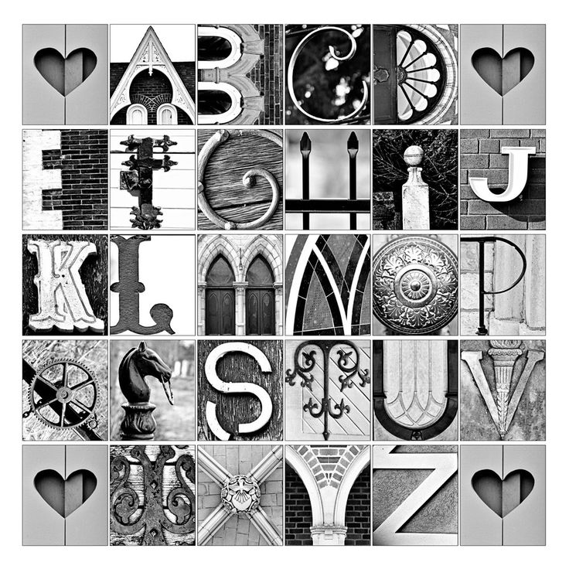
You need to collect 3 different images for each letter in the alphabet

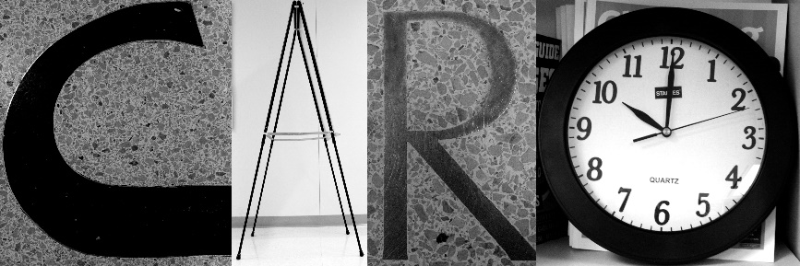

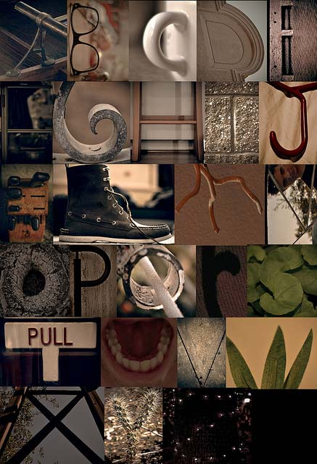

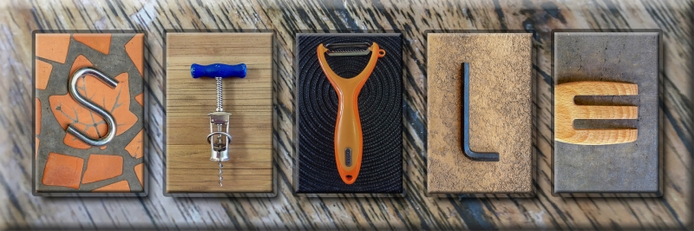

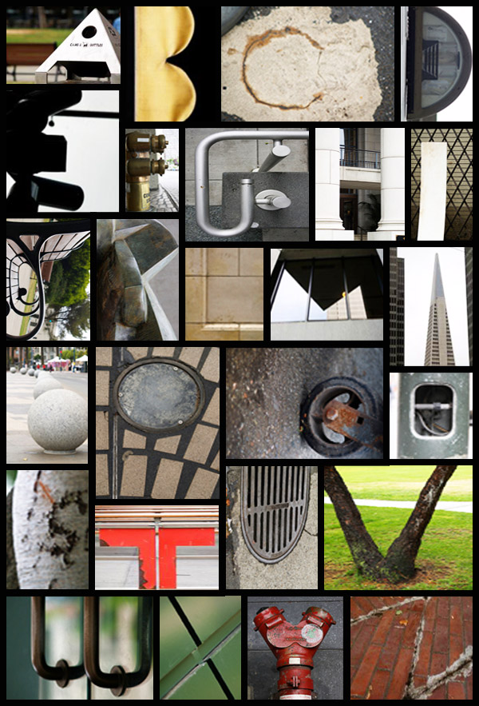
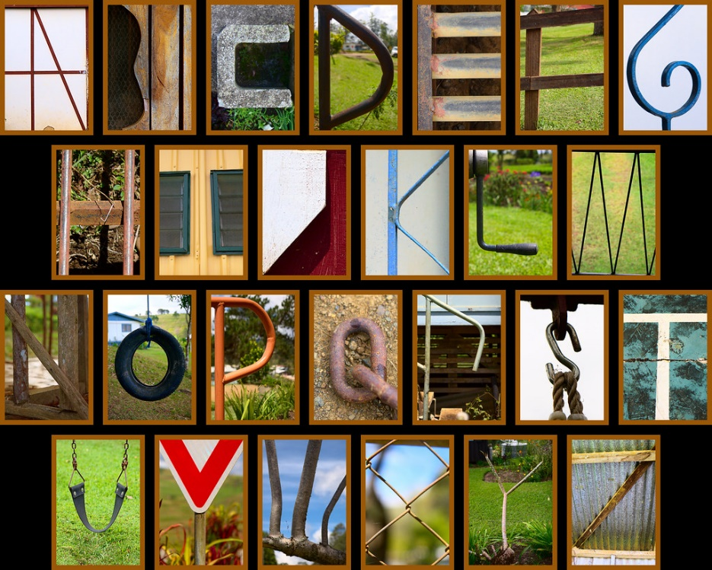

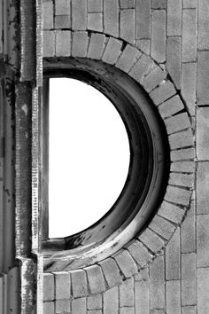
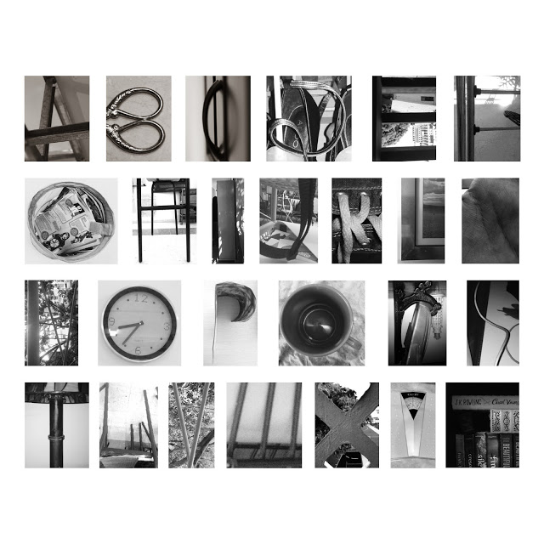
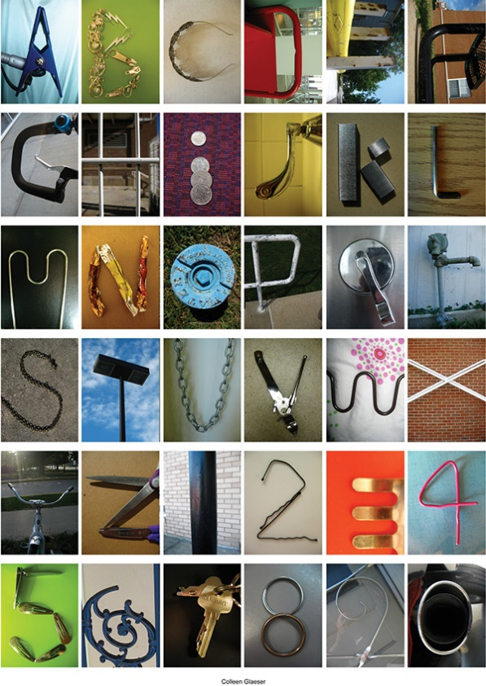
Happy holidays, Mrs Owen
Use these images for inspiration but don’t copy them…. This is an exercise in creativity… I want to see what your imagination is capable of…

